

# Bakerz Bite

**Supervisor:** *NGUYỄN HẠ VY*

**Semester:** *01*

**Batch No:** *T1.2210.A1*

**Group No:** *01*

|  |  |  |
| --- | --- | --- |
| **Order:** | **Full name** | **Roll No.** |
| *1.* | *NGUYỄN QUỐC BẢO* | Student1424293 |
| *2.* | *TRANG SĨ DUY HIỂN* | Student1424200 |
| *3.* | *TRẦN THANH BÌNH* | Student1424195 |
| *4.* | *TRẦN THANH TỶ PHÚ* | Student1424190 |

***Month****: 11* ***Year****: 2022*



This is to certify that

**Mr. NGUYỄN QUỐC BẢO Mr. TRANG SĨ DUY HIỂN Mr. TRẦN THANH BÌNH**

**Mr. TRẦN THANH TỈ PHÚ**

Have successfully Designed & Developed

# Bakerz Bite

Submitted by:

**Ms. NGUYEN HA VY**

Date Of Issue:

Authorized Signature:

# Content

Content Acknowledge Synopsis

Review 1

Review 2

Review 3 ..

Tasksheet ..

# Acknowledge

As we understand that the eProject is a step-by-step learning environment that closely simulates the classroom and Lab-based learning environment into actual implementation. It is a project implementation at your fingertips!! An electronic, live juncture on the machine that allows you to.

* Practice step by step i.e. laddered approach.
* Build a larger more robust application.
* Usage of certain utilities in applications designed by user.
* Single program to unified code leading to a complete application.
* Learn implementation of concepts in a phased manner.
* Enhance skills and add value.
* Work on real-life projects.
* Give a real-life scenario and help to create applications that are more complicated and useful.
* Mentoring through email support.

First of all, I would like to thank India Aptech for allowing my team to work on this fantastic eProject. We had a great experience with eProject this time.

Next, We would like to express my special thanks to our mentor, Ms. Ha Vy for the time and effort that she provided throughout the project. Your helpful advice and suggestions were beneficial to us during the completion of the project. In this respect, We are forever grateful to you.

Besides several mistakes we made in the project, we hope to have more opportunities to widen our knowledge in the web-developing world.

We will try to continue to learn and improve ourselves even more in the future.

Yours Sincerely, Team Group 03.

# Synopsis

The Objective of this program we aim is to give a sample project to work on real- life projects. These applications help us build a larger more robust application.

The objective is not to teach us HTML/JavaScript but to provide us with a real-life scenario and help us create basic applications using the tools.

Hence, we can revise the chapters before we start with the project.

This project is meant for students like us who have completed the module of HTML5. These programs should be done in the Lab sessions with the assistance of the faculty if required.

The website (in this project) is a tool that brings everything in the world to you such as historic monuments information natural knowledge and skill in technology...

It is very essential for us that will have a clear understanding of the subject. We think we should go through the project and solve the assignments as per the requirements given.

And get back [***eprojects@aptech.ac.in***](mailto:eprojects@aptech.ac.in) as the assigned schedule.

## Problem Definition

Since its launch, “Bakerz Bite” has developed into a reputable bakery &amp; café,

specializing in baked goods, passionately made from the finest ingredients.

Bakerz Bite offers a wide range of baked goods made fresh in-store every day. The

bakery chain offers more than 300 different kinds of baked goods, including artisan

pastries, gourmet cakes and desserts, and handcrafted beverages.

The brand takes pride in sourcing and using carefully selected ingredients and promises

to bring freshness and quality to its customers. Bakerz Bite continues to expand and

embrace innovation in all markets.

We believe and are dedicated in delivering premium quality products. So we only use real

butter, cream and unbleached flour. We treat our Customers as our family and will not

use any ingredient which we will not want to feed ours.

*Our Motto: Where smiles are served daily.*

**Requirement Specification:**

The Web site is to be created based on the following requirements.

1) The Top of the Page should be presented with a suitable logo and a banner

with images of Cakes, Pastries, Cookies etc.

2) The site must contain sections like Cakes, Pastries, Cookies, Pies etc. and

should consist various items.

3) Clicking on any item should open pop-up window with images of product

along with the description and detailed specification (ingredients).

4) Site should also consist of a section “Merchandise’ with “Bakerz Bite” branded

Mugs, Bags, Glasses, Trays listed into it.

5) Filters should be provided for assisting user to select products of their choice.

6) Gallery should be added for viewing different images.

7) Feedback and Rating must be allowed to enter by the viewer

8) Site map, Gallery, about us, FAQ link, Contact us link must be added.

9) About Us and Contact Us: This menu option should display Email id, address,

and contact number.

10) Section for various offers in the store should be provided with listing of offers

with details.

11) Color combination must be uniform throughout the project.

12) Navigation must be smooth.

- Gallery

6) Navigation of the project must be made precise

7) Look and feel must be made user friendly.

## Customer Requirements Specifications

### User:

#### input:

* Information on search.
* Data of registered members.
* Data of signed-in members.
* Comment and rating starts for website .
* Feedback and compliment of user through user’s email.
* Change quantity of product in checkout page

#### Process:

* Find data on searching
* Check the data of registered members and store that data.
* Check the data of signed-in members and store that data.
* Check, store the comment and rating stars of users.
* Check, store the feedback or message of users.
* Calculate price base on user’s change

#### Output:

* Return result of searching and display infomation.
* Confirm the data of registered members.
* Confirm the data of signed-in members.
* Render user’s comment and stars rating to the Review section
* Confirm the feedback or message of the users.
* Update total money of the order which will be paid when user want check out.

### Hardware/ software requirement:

#### Software:

* + Notepad/HTML editor
  + Dreamweaver
  + IE 5.0/ Netscape 6.0

#### Hardware:

* + A minimum computer system that will help you access all the tools in the courses is a Pentium 166 or better
  + 64 Megabytes of RAM or be

Home

|  |  |
| --- | --- |
| **Document Name**:  Architecture and design of the project | **SWD/Form** No.03/ARD/Ver1.0 |
| **Version** 1.0 | **Page 3** |

User

Blog

Contact Us

Gallery

About Us

Product Details

Check out

Shopping Cart

Feedback and Message

Location

Blog Details

Login

Register

1. **Interactive with web at Homepage**

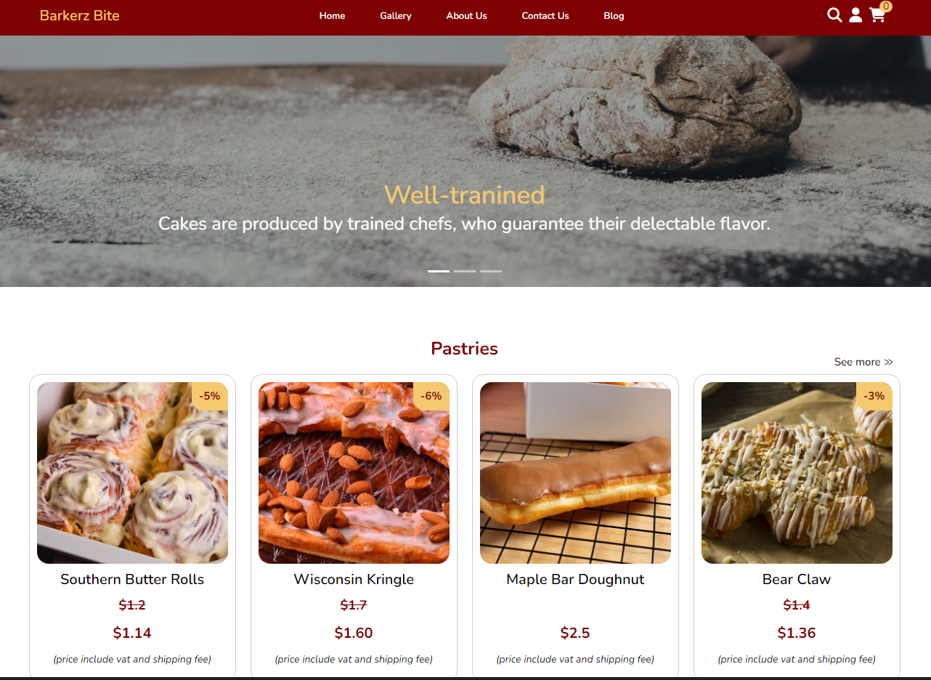

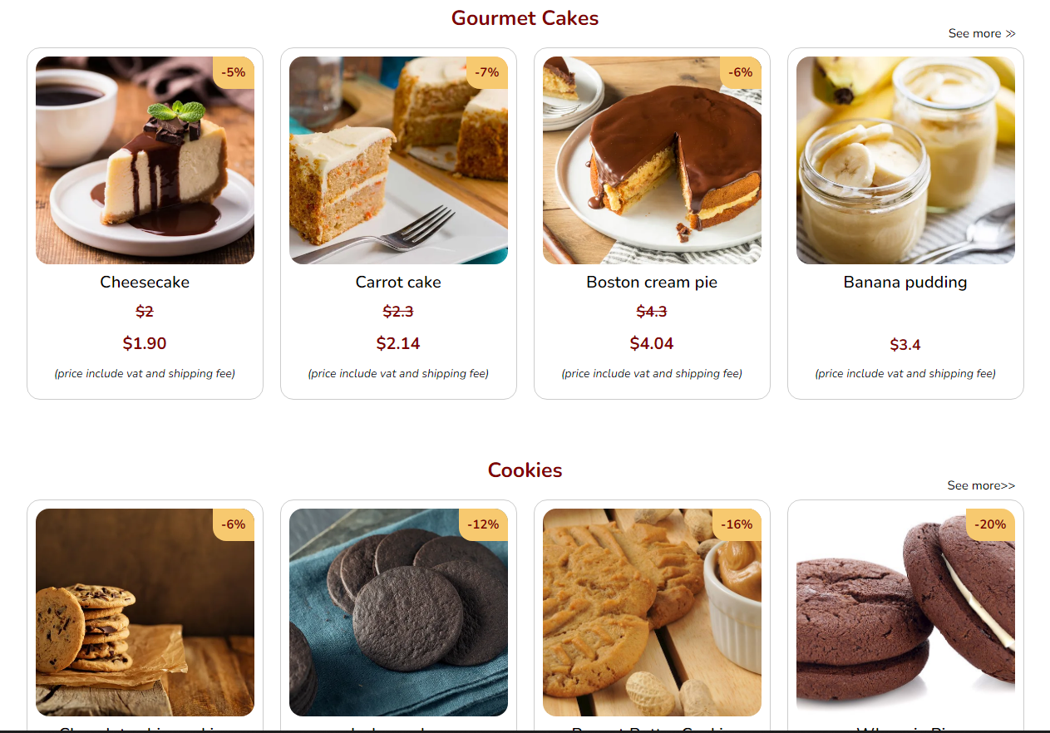



When you click buttonn , that lead to gallery with corresponding section(pastries, gourmet, ….).

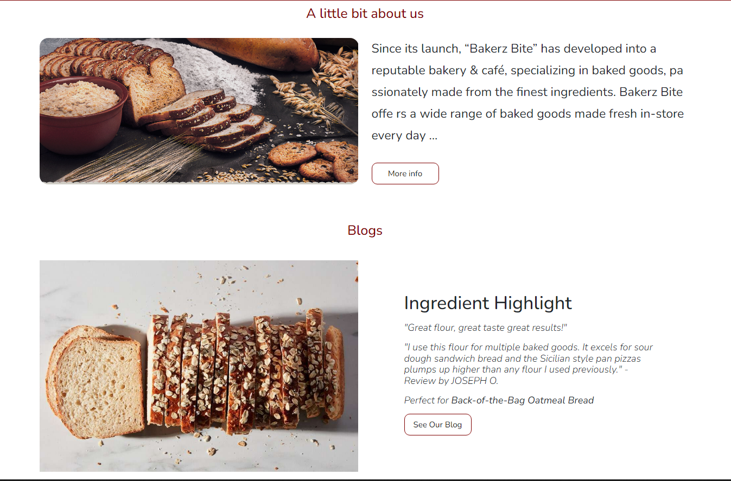- Click the button like “More info” or “See our blog”, that navigate you to About us or Blog page.

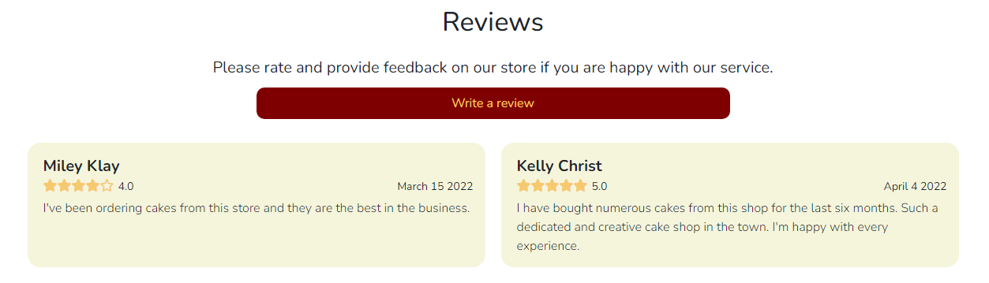

- Here is Reviews section. You can leave a comment and rate star to website if you satisfy with the service.

1. **Gallery**

.

* + Signup form and if signup success.

|  |  |  |  |  |  |  |  |
| --- | --- | --- | --- | --- | --- | --- | --- |
| No | Member | Contents | Page Name | Activity Plan | Date of Preparation of Activity Plan | | |
| Planed Start Date | Actual Start Date | Actual End Date | Status |
|  | Hứa Trường An | Home page | index.html | 16/11/2022 | 20/11/2022 | 15/12/2022 | 100% |
| Blog Details | Blog-details.html | 17/11/2022 | 21/11/2022 | 15/12/2022 | 100% |
| Blog | detail.html | 18/11/2022 | 21/11/2022 | 15/12/2022 | 100% |
|  | Nguyễn Văn Thân | Menu | Menu.html | 18/11/2022 | 21/11/2022 | 15/12/2022 | 100% |
| About | login.html | 18/11/2022 | 21/11/2022 | 15/12/2022 | 100% |
| Product details | SignUp.html | 18/11/2022 | 21/11/2022 | 15/12/2022 | 100% |
|  | Lê Bá Thành | Menu | menu.html | 18/11/2022 | 21/11/2022 | 15/12/2022 | 100% |
| Cart | cart.html | 17/11/2022 | 20/11/2022 | 15/12/2022 | 100% |
|  | Trần Cao Minh Đức | Contact | contact.html | 18/11/2022 | 20/11/2022 | 15/12/2022 | 70% |
| Login | about.html | 18/11/2022 | 21/11/2022 | 15/12/2022 | 70% |
| Signup | SignUp.html | 18/11/2022 | 21/11/2022 | 15/12/2022 | 70% |

Task sheet